Team 20

Lab number 5

Design

March 22nd, 2013

Version 1.0

By signing below, each group member approves of this document and contributed fairly to its completion.

Raymond Tang, Andrew McMillion, Archit Rupakhetee, Tyler Lenig

On our honors, as students of the University of Virginia, we have neither given nor received unauthorized aid on this assignment.

Raymond Tang, Andrew McMillion, Archit Rupakhetee, Tyler Lenig

**Contents**

**Design Overview** 3

BaseStation 3

GUI 3

Bluetooth 3

SensorInterface 3

**UML Diagrams** 3

Class Diagram 3

Sequence Diagram 3

Concurrency Diagram 3

**Anticipated Changes and Risks** 3

# **Design Overview**

## BaseStation

The BaseStation class will be the main driver for the control-station platform; all other classes will be run through this class. This class will contain the main logic and decision-making as well as the logic for controlling the robot’s motors. Therefore, this class will interact with all the other classes.

The BaseStation class will receive information from hardware buttons and display the information through the GUI via an overloaded handleEvent() in the GUI class. It will send that information to the robot through the Bluetooth class. The BaseStation class will also receive information from the robot’s on-board sensors via classes that implement SensorInterface and relay it to the GUI. This allows the BaseStation to hide how our entire system interacts and relay information to the GUI, which enables greater modularity, lower coupling, and increased cohesion.

## GUI

The GUI class is driven by the BaseStation class. It interacts only with the BaseStation class. It receives information to display from the base station and presents information to the BaseStation class if given any information in the GUI from the user. The GUI class will include functionality to accept input from the user via text fields, as well as display information given by the sensors and errors an embedded textbox.

## Bluetooth

The Bluetooth class will be responsible for encoding and decoding the 11-character string specified by the Communications Protocol. It will send and receive information from the robot via the built-in LeJOS Bluetooth connection. The Bluetooth class will also be responsible for sending information to the correct classes based on the type of the decoded information. For example, it will relay an error message or a command acknowledgement to the BaseStation and will relay sensor information through the respective Sensor class. The Bluetooth class will therefore interact with the BaseStation class and any class that implements SensorInterface.

## SensorInterface

This interface outlines the basic methods that each sensor will implement. It will interact with the Bluetooth and BaseStation classes in order to send information to the GUI and receive telemetry information from the robot. Each sensor – Microphone, UltrasonicSensor, TouchSensor and LightSensor – will implement this interface while including other methods and fields specific to the given type of sensor.

# **UML Diagrams**

## Class Diagram

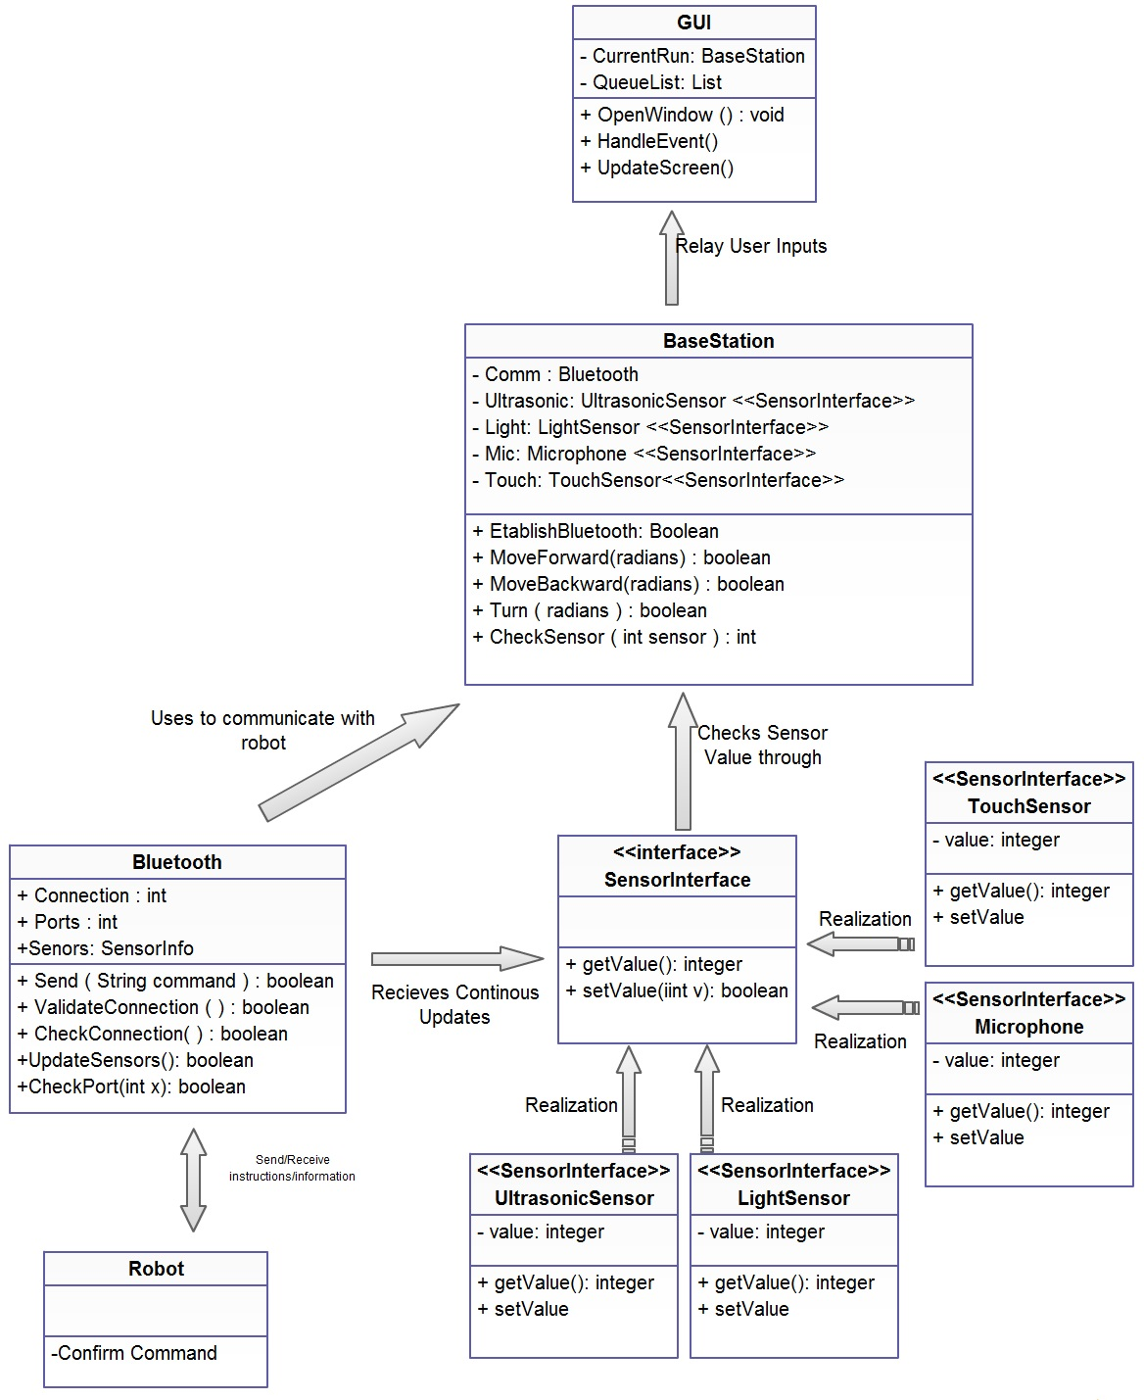

## Sequence Diagram

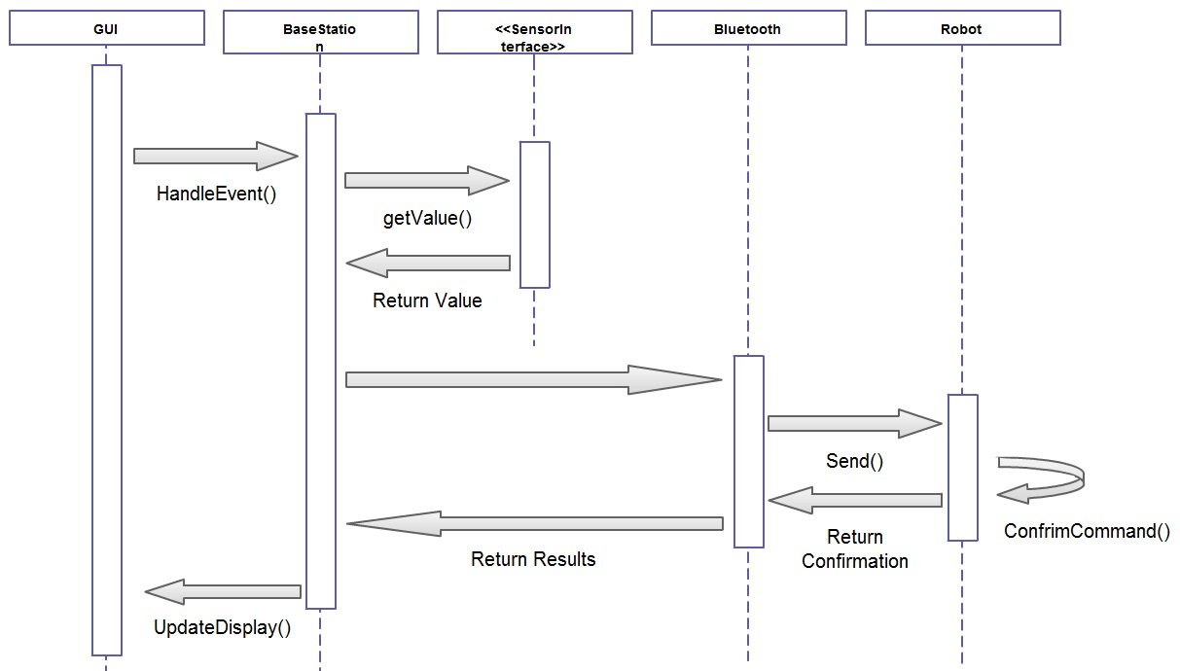

## Concurrency Diagram

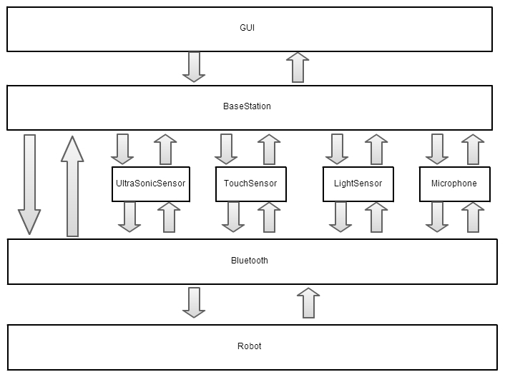

# **Anticipated Changes and Risks**

Since this document is a living document, it is going to be changed as we further investigate our design. As we analyze our design from a usability perspective, we will likely change our GUI to make it as usable as possible. We will make changes to our communications protocol after extensive testing and evaluation of our design to ensure that our communications protocol and design will function harmoniously. Our classes will be supplemented with more functionality as we see fit throughout our design and implementation process to validate our design.

We also have various risks that we have already identified as negatively affecting our design. We anticipate having issues communicating with our robot through our system which will inhibit the system overall. Another risk we are facing is that our system might be too large to fit within the constraints of the hardware. Our schedule also presents a risk to us in the manner that we might not be able to complete all of the milestones we have set before the given deadline. In order to rectify these risks and other risks that may arise, we might have to implement the aforementioned changes and other changes to the system.